Greenwood business engagement project report

Summary
The aim of this work was to co-design, with local businesses, a sustainability initiative which would be focused on behaviour change and involve an award and recognition system for businesses. We ran a series of four business engagement workshops which were tailored to answer different questions, in order to provide the evidence base and foundation for the Greenwood Initiative. Working with these proactive businesses in Meanwood enabled us to develop an initiative which is tailored to the needs of local businesses, while being feasible and applicable to all sectors and businesses. We have found that businesses in Meanwood have a very strong commitment to the local community, and good networks and connections already exist between businesses in the area. There is potential to use this strong foundation to identify opportunities to work together to solve common problems, for the benefit of businesses, community and the environment. The next steps involve expanding the engagement and involvement of businesses across Meanwood, and potentially further afield, and providing further opportunity for knowledge sharing and problem-solving within the business community.
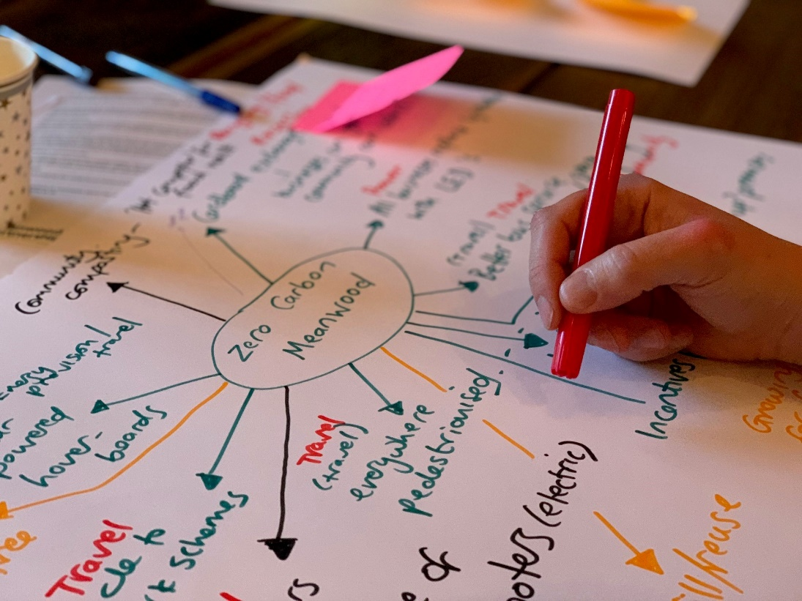

Image : Extract from the visioning exercise in workshop 1 (Image courtesy of Andrew Omond).

Research process

Business mapping
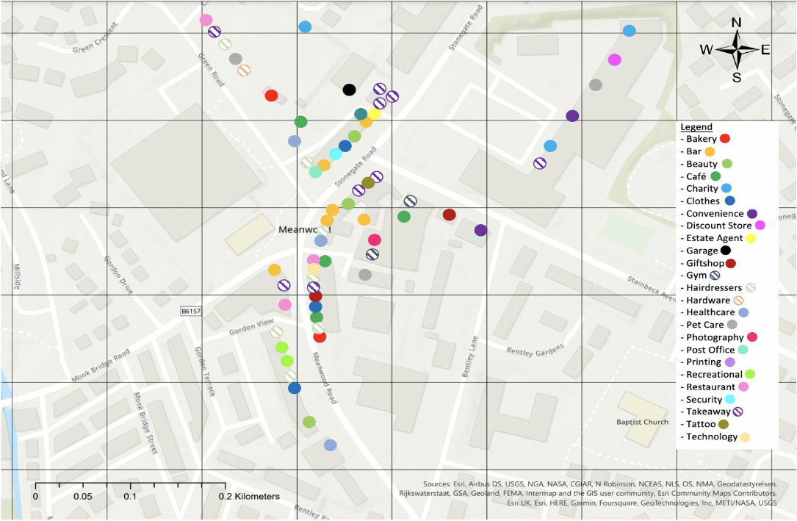
The first phase of the project involved mapping and identifying the businesses across Meanwood, in order to understand what type of organisations are present in the area (see Image 2). Understanding the business landscape of the area was important, in order to help structure the early work of developing the workshops, and also to tailor communications and outreach.

Image : Map of businesses across Meanwood (courtesy of Andrew Lewyckyj).

Business engagement
We reached out to all 68 businesses on the map, through face-to-face discussions at business premises, social media, email, and through conversations at Meanwood Market. We found the most successful and fruitful strategy was face-to-face followed by a subsequent reminder email, although social media had its use in raising the profile of activities. The most important factor was ensuring there was a clear ‘ask’ of the businesses when inviting them to the workshops, and also a clear benefit to them.

Collaborative workshops
The four workshops ran monthly from May to August, held at LightSpace, which focused on four different themes for discussion.
- Workshop 1 was a ‘kick off’ event, aimed to generate enthusiasm for the project. We ran a visioning exercise to get everyone thinking about what a sustainable Meanwood could look like, and how this related to each business.
- Workshop 2 was focused on sharing best practice and existing knowledge. What became immediately apparent was the great work already ongoing across the participating businesses. We also discussed barriers to change and potential solutions to these.
- Workshop 3 was led by Andrew Lewyckyj, and focused on participants’ perception of climate risk and motivations for behaviour change.
- Workshop 4 focused on the development the Greenwood project, with additional discussion around expanding the business engagement going forward and how to strategise this.
The attendees included SMEs (which were primarily owned and/or managed by one to two people), as well as local councillors.

Research findings
From the engagement workshops and discussions with businesses, we found that the participants were all extremely knowledgeable about climate and sustainability issues, and there was a huge amount of will to make changes for social and environmental good in their businesses, and all were passionate about the local area. The main topics of discussion common across the workshops were:

Resources and waste
‘The cardboard project’ came about in the first session, where a need was identified across all businesses: the volume of cardboard waste generated and the costs associated with recycling. Therefore the idea to find use for this resource resulted in an arrangement with the local allotments who utilise cardboard as a weed suppressant. Three businesses are co-ordinating to supply the required cardboard needs for the allotments. There is potential for this to be replicated further afield.

Infrastructure
Power and heating infrastructure (and associated costs) were a big talking point, with a major barrier being the relationship between landlord and business tenant, which could hugely impact willingness to make changes (for instance with insulation or solar PV). The crux of these issues generally was found to be the conflict between ‘who benefits’ and ‘who pays’. Potential solutions included installing non-permanent/non-structural insulation such as secondary glazing, door and window insulation, magnetic radiator reflectors, and optimising air flow, which are relatively low cost.

Finance
The issue of costs to small businesses was the most prevalent barrier to change, as SMEs face challenges making more sustainable choices with businesses up and down the supply chain due to a relatively small contracts, which creates less power to renegotiate embedded contracts compared to larger businesses. Scalability was identified as a potential solution, for instance through neighbouring businesses co-ordinating with suppliers and other contractors (i.e. for recycling, waste disposal or professional services) to increase their buying and negotiating power. This suggestion has significant potential, however will most likely need one or two independent businesses to lead and take this forward. Additional discussions around what support Leeds City Council could provide were had with local councillors, and this highlighted the need for better communication of existing financial support, therefore business support workshops and communications were suggested. Moving beyond upfront cost changes (such as infrastructure) to consider behavioural changes of owners, staff and customers could be an alternative, or complementary, strategy to improve sustainability.

Use of greenspace
Use of community space and local greenspace was seen as a potential ‘easy win’, with businesses keen to contribute to developing this further. There were also some discussions around the use of community greenspace for SMEs, who potentially could use previously unused space to grow products which are then sold locally, reducing transport emissions and costs.

Planning and use of disused business space
Some participants were small business owners who were looking for local space to utilise to grow their business. There could be interesting opportunities to facilitate local business growth through the sustainable use of disused council-owned land and property, although this will need further discussion with Leeds City Council officers and councillors.

The Greenwood Initiative:
The main output from this project has been the creation of ‘The Greenwood Initiative’ to support local businesses to increase their sustainable actions and reduce their environmental impact. This initiative aims to reward and celebrate local climate and sustainability action in businesses, and facilitate knowledge sharing to further increase the positive impact. The structure and content of this initiative was one of the primary aims of the workshops, and has been co-created by the participants across the four workshops.
The ‘Greenwood’ resources (hosted on the Love Meanwood website) provide support for businesses interested in implementing sustainable actions. We created a guide with a range of suggested sustainable actions to implement, however, these are just suggestions and businesses are encouraged to identify their own actions. The more actions taken, the higher the award! Once the business has implemented actions, they simply email pictures, screenshots or other evidence of the actions taken to Meanwood Valley Partnership (meadwoodvp@hotmail.com), who will then award them either Bamboo, Copper Beech, Silver Birch, or the Oak award.
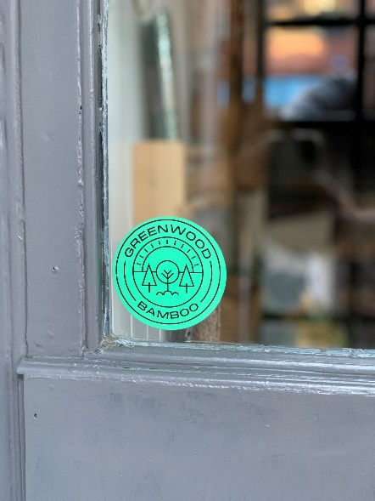
Alternatively, there could be the option of creating a tailored project. This may be appropriate for businesses with a specific idea in mind or who want to solve a specific problem (i.e. the cardboard project). The Meanwood Valley Partnership will support the project through facilitation; identifying potential partnering organisations to work with, identifying others who have achieved a similar aim, or by linking up with other potential resources (i.e. expertise or funding).

Image : Tandem displaying their Bamboo award (image courtesy of Andrew Omond)
Sharing best practice is the foundation of this initiative, with an online platform for discussion often suggested by businesses, as well as regular in-person events to share progress and problem-solve.
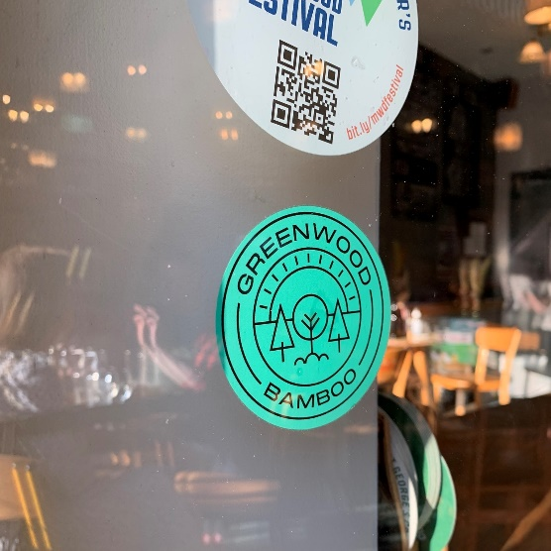

Image : Alfred's displaying their Bamboo award (image courtesy of Andrew Omond)

Celebrating the successes of businesses is vital, through regular communications both on social media and online platforms, and in-person events such as MVP open meetings and focused Greenwood workshops.

Recommendations and next steps:
- The vibrant discussions in the business and community workshops were essential for knowledge sharing and problem-solving, therefore regular in-person opportunities for business community building would build on this momentum. This could be structured through focusing on a specific local issue (e.g. around supporting community events to be more sustainable, increasing and improving greenspace or community areas, or working together to influence issues such as planning, developments or transport). Alternatively (or additionally), these business community workshops could be facilitated to focus on business focussed sustainability issues and problem-solving. Suggestions for future topics include insulation and retrofitting, supply chain opportunities, how to reframe waste as a resource, and how to influence customer and client sustainability practices. Businesses were keen to attend these events quarterly to maintain momentum.

- Through discussions between businesses and local councillors, dedicated business support workshops were suggested, where Leeds City Council outline the full range of business support available. Engagement with local councillors was beneficial for the businesses, who utilised the space to directly highlight local issues which were creating barriers to implementing sustainability actions.

- There was appetite from business for a platform for ad-hoc business engagement and discussion. This could be created as a virtual forum space on the Love Meanwood website, where people and organisations could pose questions and share success or progress. There was reticence towards utilising social media platforms for this purpose as it would be ‘just another thing to check’, whereas a dedicated space would provide focus for the discussion.

- Celebrating success and best practice is hugely important to businesses. There are several existing prominent platforms used by businesses and the community, such as the Meanwood Matters network as well as the MVP social media. A monthly sustainable business feature was suggested.

- The process of engaging with businesses from the outset, in order to help co-design the Greenwood Initiative, ensured relevance to small and medium sized enterprises. Centring businesses and organisations in the creation and moulding of the initiative should continue.

- Business engagement was the hardest barrier faced by the team, with those businesses engaged in the project already implementing sustainability as either a core part of their business, or through the participants’ individual interest. Dedicated marketing support should increase engagement, utilising the Love Meanwood website (including an interactive forum) combined with other communication channels (e.g. ‘That Leeds Mag’, community events, and social media).

- The strong sense of community in Meanwood is a huge positive building block on which to expand the Greenwood Initiative, through utilising strong community networks (both in-person and online).

Acknowledgements
Many thanks to the Leeds Social Sciences Institute (LSSI) at the University of Leeds for funding this research placement, and The National Lottery for funding supporting the Greenwood project.
In addition to the core Greenwood project team (Janet Matthews, Andrew Omond and Carolyn Mackay), Andrew Lewyckyj (MSc Sustainability student) and Catherine Graves (PhD researcher), both at the University of Leeds, supported this project.
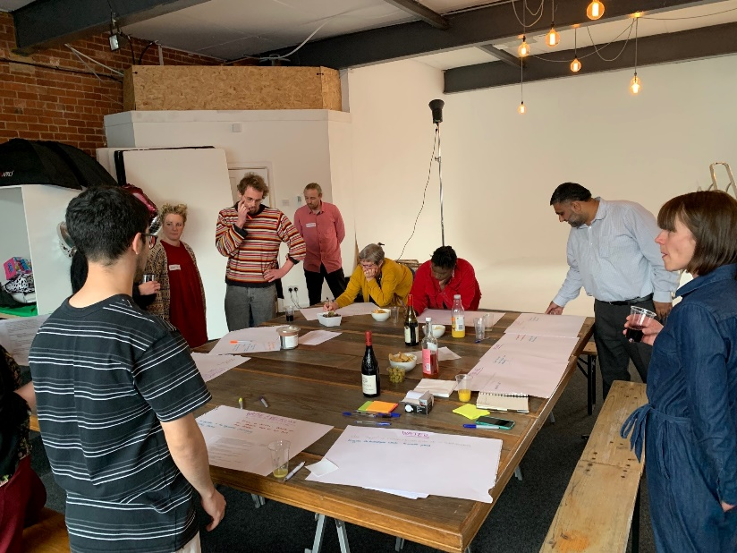
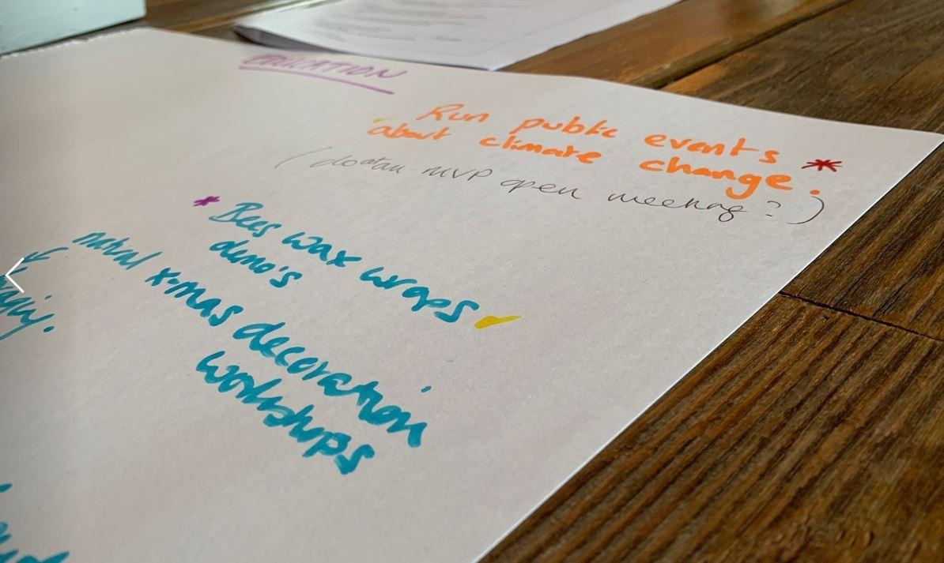
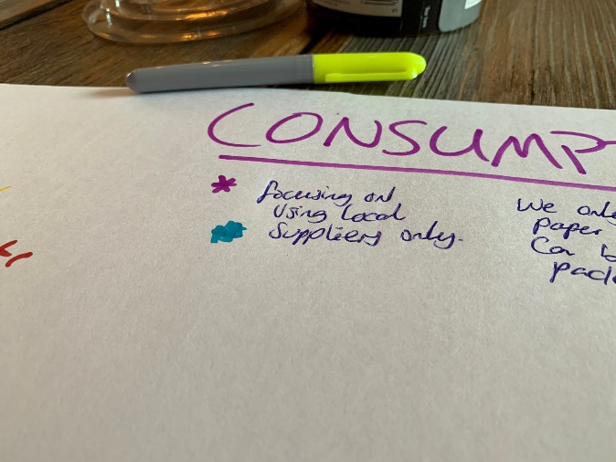
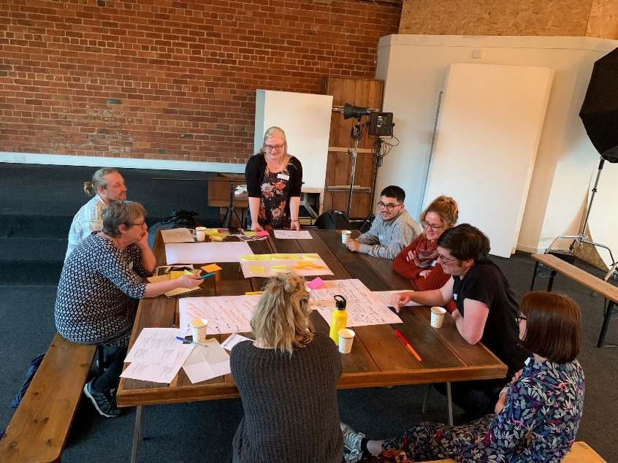

Image 5: Andrew Lewyckyj leading workshop 3 (image courtesy of Andrew Omond)

Image 6: Extract from workshop 1 (image courtesy of Andrew Omond)

Image 7: Extract from workshop 1 (image courtesy of Andrew Omond).

Image 8: Photo from workshop 1 (image courtesy of Andrew Omond)

